HINTON 2016
APBA Stock Mod Junior Nationals

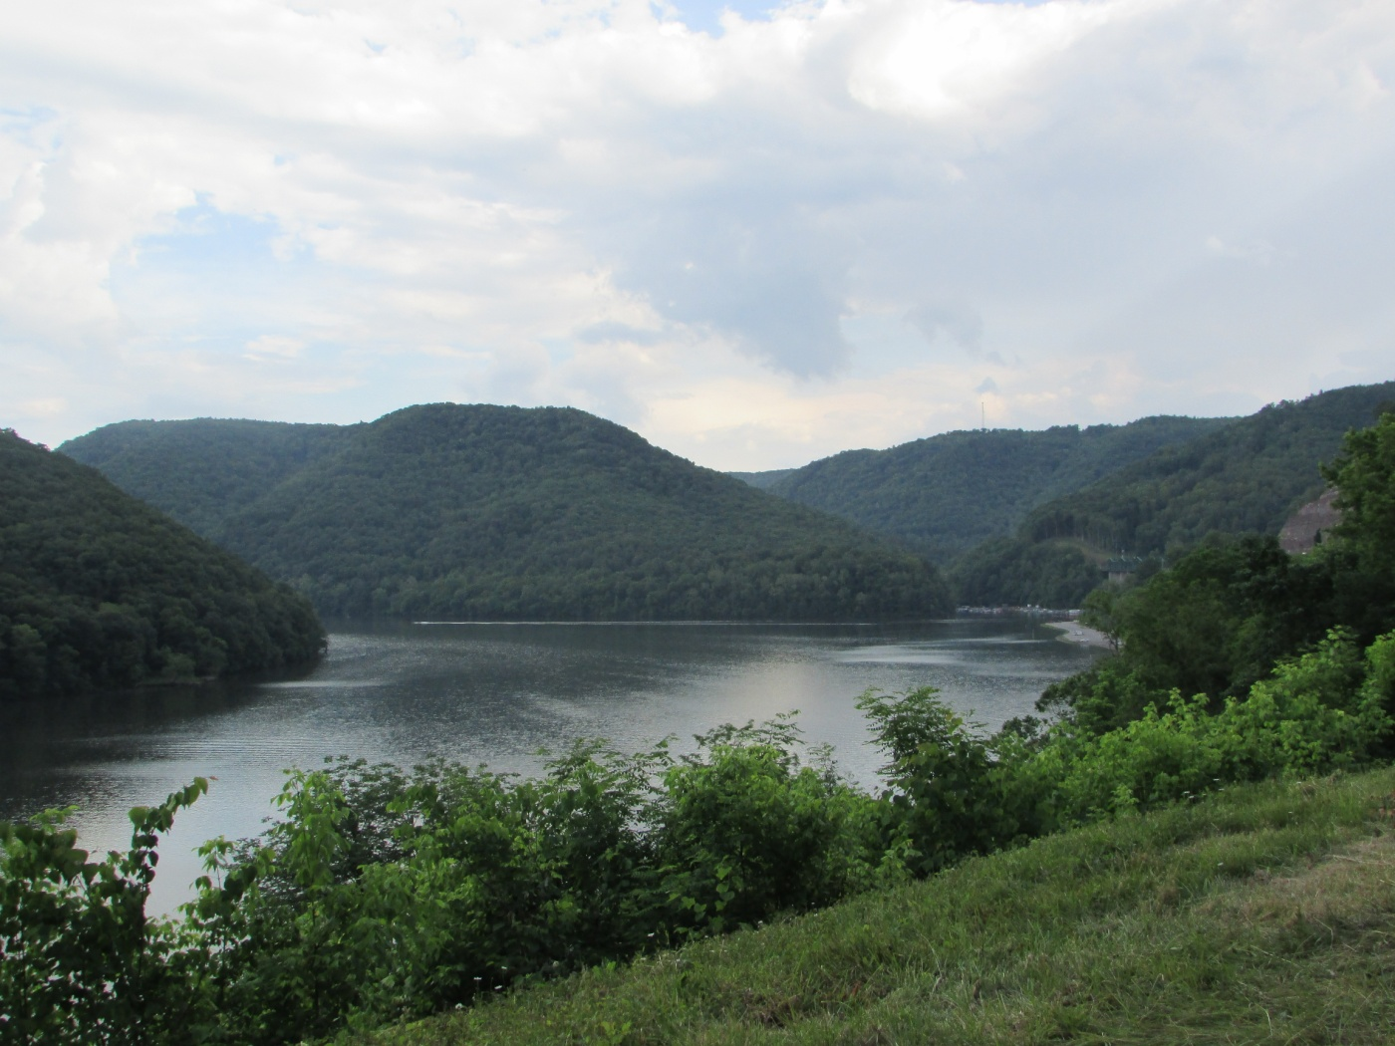

Location: Bluestone Lake
Hinton, WV
GPS Coordinates:
37.618326, -80.915508

Dates: July 31st- August 6th

Schedule of Events

Sunday  7-31-16 | Registration  Pit Move-In  “Open Night”
Monday  8-1-16 | Registration  Testing  Driver’s Meeting
Tuesday  8-2-16 | Qualifying Heats  Hinton History Night/  Taste of the Regions
Wednesday  8-3-16 | Qualifying Heats  “Open Night”
Thursday  8-4-16 | Qualifying/Finals Heats  Qualifiers Banquet
Friday  8-5-16 | Finals Heats  “Open Night”
Saturday  8-6-16 | Blowout Day/  Finals Heats  Finals Banquet

FAQs
- What are the dates?
July 31st- August 6th

- What is the entry fee cost?
$60.00 per class

- Where should I stay?
Please see lodging list or visit
www.exploresummerscounty.com

- Where can I get more info on outings, things to do, etc?
Contact New River Gateway CVB at 304-466-5420 or visit their website at www.exploresummerscounty.com

- How should I register?
Online pre-registration should be available in late spring 2016, stay tuned for updates on our Facebook page, APBA social, and Hydroracer.

- How do I reserve a pit spot?
The cost of each pit space will be $10.00.

Pit spaces will be available for purchase through online pre-registration or actual registration at Nationals.

We will do our best to accommodate requests to pit close to family/friends.

- Will testing be available?
Yes, sanctioned testing will be held on Monday,
8/1/2016.

