Power Boat Racing

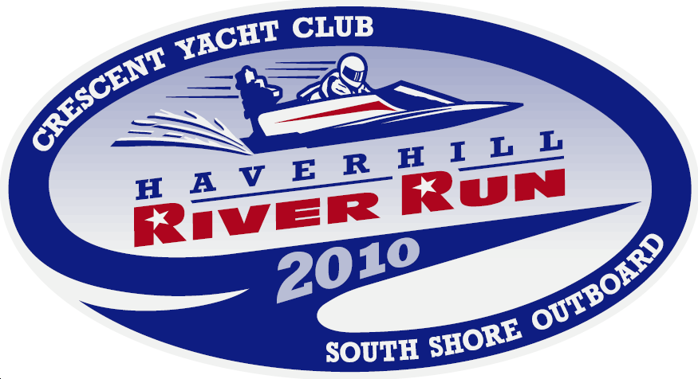
August 28 & 29
Noon to 5:00 pm

American Power Boat Association Certified Races

Hydroplane and Runabout Race Boats

80 Boats Competing from the US and Canada

Northeast Divisional Marathon Championship

Race viewing at CYC & Buttonwood Trail

View Race Boats - Cookout all Day @ CYC

Crescent Yacht Club
30 Ferry Street, Bradford, MA 01835

www.HaverhillRiverRun.com

