Tohatsu for Competition Only

By Bass Machines

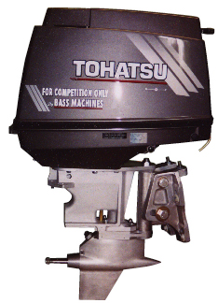
The Tohatsu Competition only by Bass Machines is a carbureted 50 HP Tohatsu power head mounted on a Bass Machines tower housing, adjustable bolt-on transom bracket, and lower unit. The engine is complete with steering bars, throttle connection, and fuel hose. Hood may be a different color combination.

This engine is approved by APBA, AOF, and NBR for several stock or modified classes. Check with your association to get the current racing rules. Purchase of this engine requires proof of intent to use the engine for competition only. Proof of membership in one of the above national organizations or another similar boat racing organization is suitable for proof of authority to purchase.

The carbureted 50 HP Tohatsu M50D2 power head is imported under a competition waver from EPA and is only available as a complete racing outboard motor from Bass Machines. The carbureted M50D2 Tohatsu is sold worldwide and was sold in the United States and Canada until EPA emissions restrictions caused the same basic power head to be sold only as a fuel injected model complying with all EPA regulations. Parts for the M50D2 power head are readily available from your local Tohatsu or Nissan outboard motor dealer. All specialty-racing components are available from Bass Machines.

General Description:

Three Cylinder, Two Cycle, Carbureted
Displacement: 42.5 cu. in. (697cc)
Bore & Stroke: 2.68 x 2.52 in. (68 x 64 mm)
Approximate Weight: 140 lbs.
Induction: Loop Charged
Ignition System: Capacitor Discharge, One Coil per Cyinder
Manual Start with Recoil (Electric Start Available)
Water Pump: In Tower Housing Above Lower Unit
Lower Unit Shaft: 11/16th in.
Shear Pin Hole: ¼-in.
Gears Available: 17:17 or 16:17
Horsepower Curve

“Based on the dyno runs, the two engines have different powerbands. With the additional Torque of the Tohatsu engine over a wide RPM range it can and will pull more blade area. Because the engine falls off at high RPM, more pitch would be required for top speed, and there is power to pull that pitch. More Torque, equals stronger acceleration.” (WIENANDT Performance Technology Report requested by APBA SORC)

Micro-adjust Transom Mount

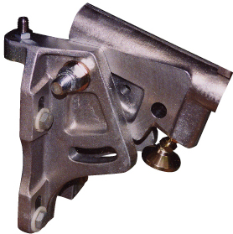
The micro-adjust transom mount is a durable heat-treated aluminum casting with machined surfaces and micro adjustments for engine height and kick-out. The photograph shows the saddle in the tilted up position to expose the adjustable pad for kick-out. The kick-out can be micro-adjusted and held firmly in place by tightening the pad jamb nut. Further, the ¾-inch bolts (one shown) can be tightened to over 100 ft-lbs. Any potential slip in kick-out is prevented by the transom adjustment pad and locking nut. One of two micro height adjustments is shown. Each adjustment bolt has a socketed pad that rests against the top of the transom and a jamb nut to hold the position.

This mounting system also provides some very badly needed safety security. The engine is bolted to the boat, and the kick-out is firmly bolted in place. There is no danger of clamp systems coming loose or the need to rope tie the engine down.

Lower Unit

The lower unit is manufactured from a high strength aluminum casting, heat-treated and finished with a smooth bright aluminum brush finish. It mounts with a standard four bolt Konig® bolt pattern, 11/16-inch propeller shaft with a ¼-inch shear pin, and a 12mm square coupling pinion shaft. The water pickup is located low on the unit in front of the skag leading edge. A water pump is provided at the Bass Machines tower housing. The unit has been primarily used for racing engines developing 75HP in the D-mod, E-mod, FE, and SE classes.

Lower unit gear ratios are available in 17:17, 16:17 and 17:16 overdrive can be provided by reversing the mounting of the 16:17 set. Gears are manufactured of alloy steel, carbonized and hardened, and spine mounted to ground high strength heat-treated shafts.

Assembly and disassembly of this lower unit requires no special tools or jigs. The shafts, bearings and gears are all assembled onto a bearing block that is inserted into the housing and held in place by a locking bolt and bar. The unit is fully o-ring sealed against water intrusion.

Minimum Finish Dimensions (inches)

Q | T | U | V
11.7 | 5.0 | 3.0 | 4.0

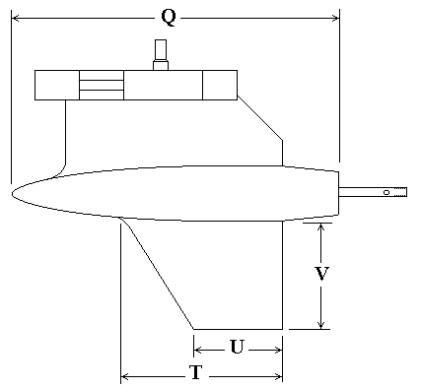

W | S | R
4.4 | 2.0 | 2.0

